Supplementary Materials
Contents

- Computational information of the binarization process ……………………………2
- Enlarged image of the Figure 3 (Original Figure 2) ……………………………….2
- Mathematically description and pseudo-code of particle motion …………………..3
- Gradient vector smoothing method in (Xu and Prince, 1998)……………………....4
- Heuristic rules used in tracking .…………………………………………………….4
- Example histograms of cells in four cell phases over time …………………………5
- Enlarged image of Figure 4 (Original Figure 3) ………………………...…………..6
- Validation of segmentation results .…………………………………………………7

- Computational information of binarization process
We use the same iterative procedure to estimate the background as the references (Wahlby et al., 2002; Lindblad et al., 2004). The average number of iterations is 4, and it takes about 0.625 second using Matlab 7 on the Pentium® 4 2.8GHz computer.

2. Enlarged image of Figure 3 (Original Figure 2).

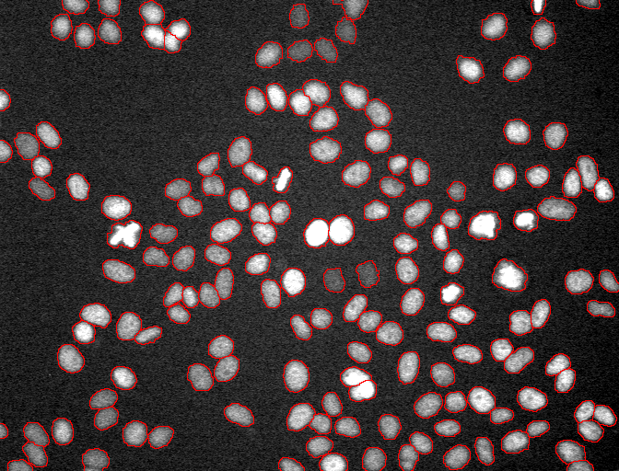
(a)

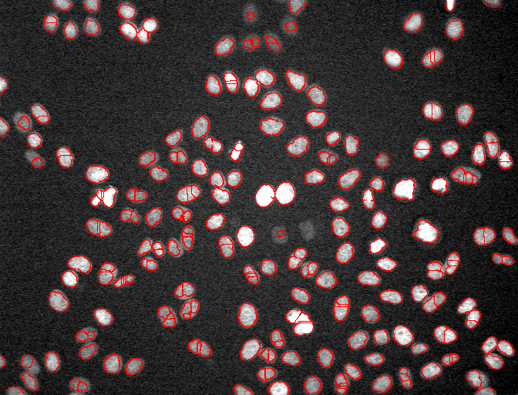
(b)
Fig.3. Segmentation results of the proposed cell segmentation algorithm. The nuclear boundaries are shown in red. (a) Segmentation result with the proposed method. (b) Segmentation result with traditional watershed based method (Yan et al., 2006).
3. Mathematically description and pseudo-code of particle motion
In the gradient vector field, each pixel has a gradient vector which points to another pixel with higher intensity or points to itself if it is a local maximum. If we place a particle, whose motion is influenced by the local gradient vector field, on a pixel location, the particle will either move from its position to another pixel or stay still (if the local gradient vector points to the pixel itself). If this particle is freely allowed to move under the influence of the gradient vector field, it will eventually stop at a local maximum. Now, we place one such particle on each pixel and let them move along the gradient vectors. Under the influence of the gradient vector field, the particles will converge to local maxima in the image. This process can be described using the pseudo-code as follows:
--------------------------------------------------------------------------------------------------------
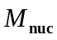; /*Nuclei matrix in which the value of background pixel is 0 and nuclei pixel is 1. The footnote ‘’ denotes the nuclei*/
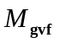; /*Gradient vector filed matrix which records the gradient vectors of each pixel, and the footnote ‘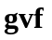’ means the gradient vector field*/
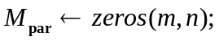 /*Particle convergence matrix which records the number of particles stop at each pixel. We initialize its elements as 0; and the footnote ‘’ denotes the particle convergence. */
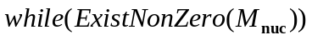
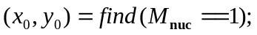/*find one nuclei pixel*/
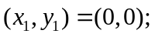/*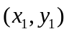is used to record the stop pixel of the particle which is put on the 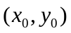*/
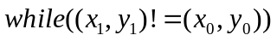
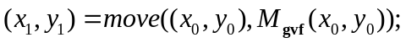
/*move the particle fromalong the direction of 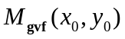 to pixel . If pixel is a local maximum, the gradient vector will point to itself, and 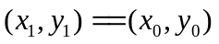which means the particle stop at this point*/
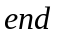
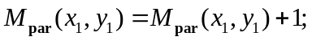
/*The number of particles stop at pixelincreases one*/
---------------------------------------------------------------------------------------------------------
4. Gradient vector smoothing method in (Xu and Prince, 1998)
In that paper, the authors smooth the original gradient vector 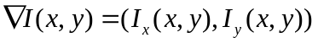 by minimizing the following energy function:
(1)
where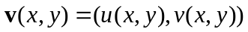 is the smoothed gradient vector. The regularization parameter controls the smoothness of gradient vector. Much smoother gradient vectors can be obtained by increasing the value of.

5. Heuristic rules used in tracking method

Two heuristic rules:
Let 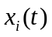 and 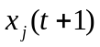denote the -th cell in frame and -th cell in frame 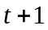.
Rule 1, for left cell , if it has a matching cell , and satisfy the following equation: where 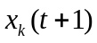is the other matching cells of . We choose 1.1 as the threshold since the area of a cell cannot increase more than 10% in the next frame in accordance to our observation.
Rule 2, for left cell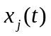, if it has matching cell 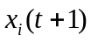, and satisfy the following equation: where 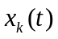is the other matching cell of . We choose 1.1 as the threshold since we think no matter the is under-segmented or the andare over-segmented fragments, the 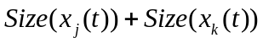 should has similar value with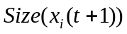.

- Example histograms of cells in four cell phases over time

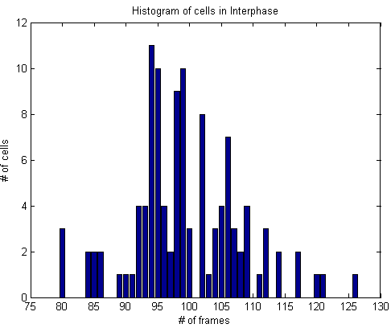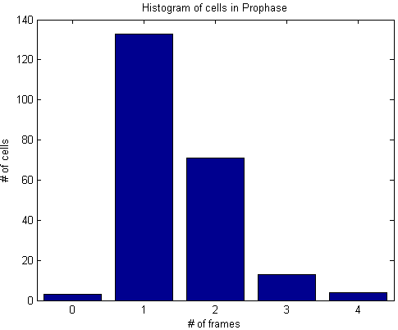
(a) Interphase (b) Prophase
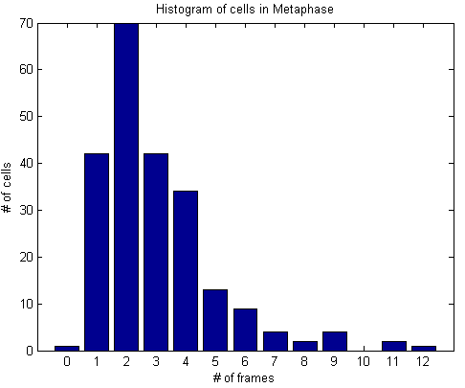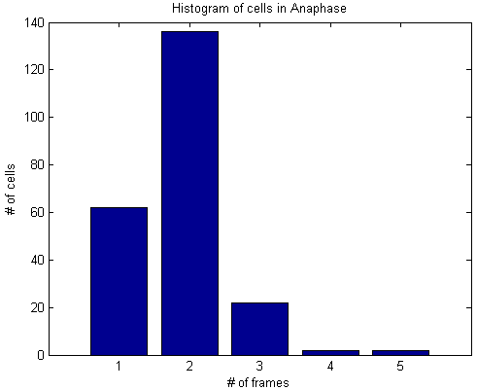
(c) Metaphase (d) Anaphase

- Enlarged image of shape descriptor features (Figure 4)

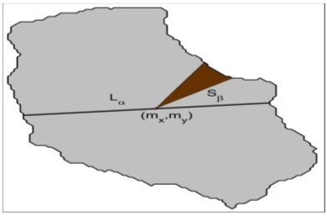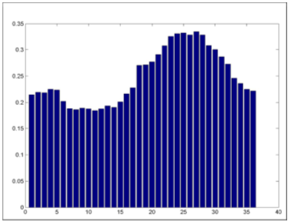
  - (b)

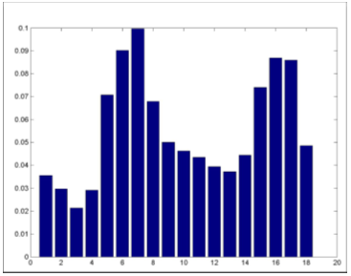
(c)

Fig.4. The illustration of computing the shape descriptor features (a) cellular region, central axis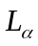, and fan bin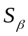. (b) The 36-dimensional ratio length feature; (c) the 18-dimensional ratio area feature.

- Validation of segmentation results

We use two metrics: precision and recall to evaluate the segmentation results. For convenience, we illustrate both of the ground truth and automated segmentation results in Fig. 5. We define the precision and recall as follows:
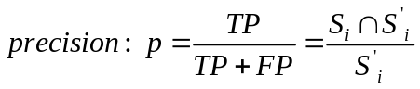, 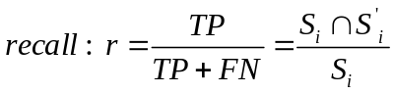,
where 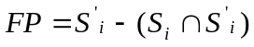, 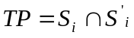, 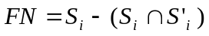. To validate the segmentation accuracy, we randomly selected 300 cells form 30 images (10 cells per image). Four people did the validation. The average precisions are 92.5%, 91.36%, 92.53% and 90.42% respectively. The average recalls are 92.38%, 90.17%, 93.12% and 91.17% respectively.
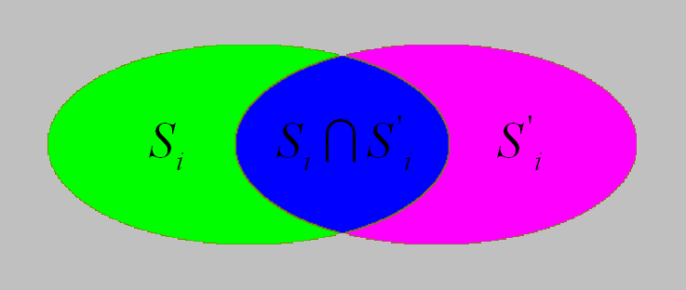
Figure 5: Illustration of the ground truth and automated segmentation result. Green and blue parts denote the ground truth; Purple and blue parts denote the automated segmentation result. Blue part denotes the common area of the ground truth and automated segmentation result. Gray part represents the common background.
To evaluate the human I.D. error, for each nucleus, we compute the human I.D. error as:
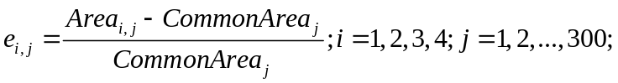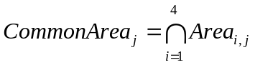
where 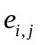is the i-th human I.D. error on the j-th nucleus. 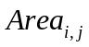is area of the j-th nucleus obtained from the i-th human. 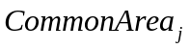is the common area of the j-th nucleus of four manual segmentation results. The average human I.D. error rate is 93.75%. In conclusion, the deviation between the automatic and manual is similar with that between the four people.

